CSC501: Module 5 – Project Milestone
11/10/2024
Nathan Rogers

Project Design
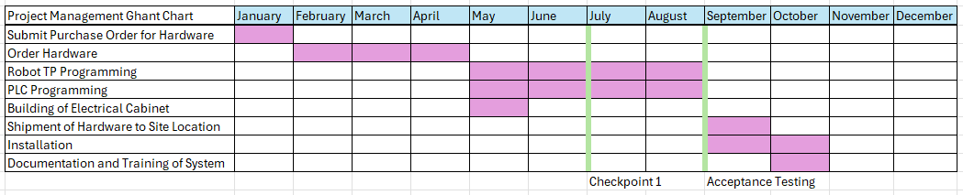

The above Ghantt Chart outlines the general timeline during the execution and integration stages of installing a robot cell in a manufacturing plant. As this is a hybrid methodology approach, a predictive plan is worked out so that a budget can be put in place, but the actual execution of this project is an agile one with sections of work followed by checkpoints from the customer (Vitro).
Before this timeline can be put in place an iterative design process must take place. The project manager, engineers and design engineers must meet to go over the specifications to then put together a design drawing. This drawing includes all measurements and full-size layout of the project to ensure that it is feasible given the existing plant layout and space constraints. In this stage we figure out what needs moved/repositioned on this existing line to make the new hardware fit, if any modifications at all. This design process can last a few weeks as the design engineer and project manager draw up several options. Once an option is selected and is approved by the project manager, engineers, plant manager and integrator, the timeline plan in the Ghantt Chart can start to take place. A list of materials is generated from the integrator, in this case we will use STAR (An Italian systems integrator that specializes in Fanuc Robot Cells).
STAR will then order all materials needed for the project and will start the timeline. Once all the hardware arrives, they can build the cell at their facility; an exact replica of how it will be installed at our facility. Once the building is completed, they can begin to program the Teach Pendant robot program, the Ladder Logic program and any electrical equipment in the cell. Halfway through the project we will send them test glass that they will use to validate their process and programming. We will also use these pieces as a verification test during checkpoint 1 and the acceptance testing. If anything is discovered during these checkpoint tests, STAR will start their iteration process and document any changes needed to meet customer requirements. Once their iteration is complete, we will have a follow-up meeting to discuss and test changes made. Upon acceptance of the equipment the next stage can start, which is scheduling installation and shipping. As STAR is an international company, we must submit customs forms for Italy and the United States to be able to ship, by boat, all equipment to then accept the equipment at the shipping dock.
When the equipment is finally at our facility, STAR will send integration engineers to assist with installing all the equipment on the line and assist in making any modifications to the existing equipment. Maintenance and local engineering will be the main drivers and share the bulk of the responsibility at this stage. Unforeseen problems can arise at the installation stage such as needing additional funds due to something being more expensive than originally quoted at the budget planning stage. Other bugs can arise also with cell programming, however that is to be expected. The integrators will then debug the robot cell until all specifications and requirements are met. This process can take a few days to a week or two depending on the severity of the bug. Once installation and debugging are complete, local maintenance and engineering are trained on the system, how to operate it and make modifications if needed in the future.
Even after installation, Vitro and STAR maintain a working service contract that if anything arises after a certain amount of time after project completion then they will come back and fix any issues that fall within the terms of the contract. At this time, the project is Vitro’s responsibility and takes ownership moving forward.

